Template for Abstract – WTC 2026, Rio de Janeiro (Title of the work)
First author¹, Second author², Third autor^{3*},………….

¹⁾ Laboratory of Tribology, Engineering School, Federal University, Brazil
²⁾ Second author affiliation, Country
³⁾ Third author affiliation, Country
*Corresponding author: corresponding author e-mail

This section (summary) must be no more than 100 words. This is an example of a proposal for WTC 2026. Authors are required to use this Microsoft Word template file and then convert it to a PDF file for submission. The template provides Style formats and a layout of necessary elements. The abstract should be written in English, including figures, tables, and references. It should not exceed 1 page and 2.0 Mo (megabyte) for the PDF file. Figures or schemes cannot exceed one-third of the page. References (no more than three) should follow the format given below.

Keywords (from 3 to 5 max): tribology, paper, MS Word template, style

Introduction
The extended abstract must be written in English, should include references, and can include figures, and tables. It should be one page long, and it is recommended to be structured into the following sections: Introduction, Methodology, Results, Conclusions, and References. Abstracts should be formatted in two columns, with a spacing of 20 mm between the columns. All text must be fully justified within the margins. We recommend using a 10-point Times New Roman font for the body text. The margins for this template should all be set to 20 mm.
The title should be centered at the top of the first page and formatted in boldface with a 14-point Times New Roman font. Following the title, include the author's name and affiliations. The corresponding author must also provide an email address.
All headings should be numbered with Arabic numerals and aligned with the left-hand margin of the column. We recommend using a 10-point Times New Roman font in bold italics for subheadings. All abstracts must utilize SI units in the text, figures, or tables.
Cite references in the text using numbers in square brackets, e.g., [1]. In the reference list for journal articles, include the first author's name (followed by "et al." for multiple authors), the article title in quotation marks (with title capitalization), the publication name, volume number (if applicable), issue number (if applicable), publication year, and inclusive page numbers

Methodology
Table 1 illustrates how to present data in a table. All tables should be numbered sequentially and include a caption with the table number and title, which should be referenced in the text. Place tables within the text near their first mention.

Table 1. Example of data in a table [1]
Material | D10 (μm) | D50 (μm)
MLG | 0.19 | 1.73
CDC | 0.18 | 1.29

Equation Example

(1)

Subitems
If necessary, subitems can be added to the manuscript.

Results
On this section the main aspects of the work will be discussed. Figures can be added to illustrate the results. Figure 1 is an example of how to add the figure on the abstract. All graphics must be embedded in the manuscript. Please use high-resolution images.

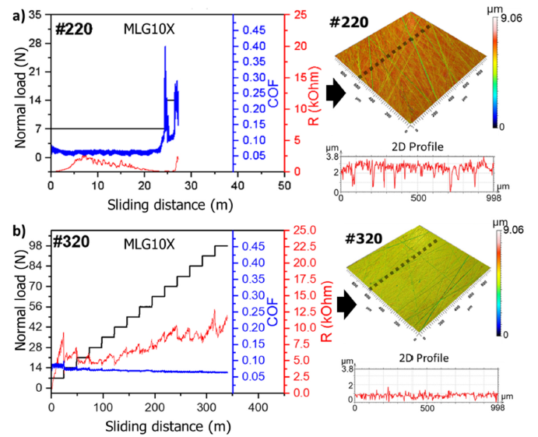
Figure 1: Example of image, maximum dimension 80 mm height and 80 mm width, adapted from [1]

Conclusions
In this section, the main conclusions should be presented objectively.
- Conclusion 1
- Conclusion 2

Acknowledgements: should follow the conclusions and not be treated as a separate topic.

References
- Giacomelli, R. O. et al., “A robust method for assessing the macroscale tribological behaviour of solid lubricant nanoparticles,” Tribol. Int., 198, 2024, 109915.

